MITACS RESEARCH PROGRESS | WEEK 13

Week 13: Pruning Comparison and Negative-AD Audit
YOLO26n dual-domain structured pruning study
Date | 15 August 2026
Status | Comparison, p56 GEN/SNOW software evaluation, and negative-AD audit completed; p56 board and external-dataset confirmation remain pending.

Purpose
This report documents the completed negative-accuracy-drop audit, consolidates the corrected 10% comparison, and adds the completed aggressive p56 software experiments on both GEN and SNOW.

Summary
- At approximately 10.25% parameter reduction, T6 has the strongest locally verified dual-domain accuracy retention, but only about 6% GFLOP reduction.
- At p56, the local GEN T7 model removes 56.81% of parameters and 47.63% of GFLOPs while retaining 94.62% of baseline mAP50-95. The matched SNOW T7 architecture retains 76.79%. These are software-validation results; matched PYNQ-Z2 measurements for the p56 models remain pending.
- All 11 negative cases reproduced exactly; all selected channels and dependency operations matched the frozen records.
- The 1,000-iteration paired bootstrap confirmed 0 robust improvement(s); the remaining cases must not be presented as proven gains.
- Batch Normalization (BN) recalibration reduced the unpruned SNOW control by 0.03532 mAP50–95, so BN-only recalibration is not recommended as an automatic correction.
- Signed AD should remain visible in T1/T2, but negative cases should receive a robustness flag rather than an accuracy bonus in the pruning decision score.

1. Matched 10% pruning comparison
The main comparison targets approximately 10.25% parameter reduction. The baseline, both Global L1 variants and the proposed T6 models were evaluated locally with the frozen full validation pipeline. Ho Yin's corrected whole-layer values are included as reported NCNN results and are kept visibly separate because the corresponding checkpoint is not available for independent local evaluation.
Table 1. Complete software comparison at approximately 10% parameter reduction
Domain | Method | Param. red. | GFLOP red. | mAP50 | mAP50–95 | Retention | Evidence
GEN | Baseline | 0.00% | 0.00% | 0.8310 | 0.6471 | 100.00% | Local full val.
GEN | Global L1, unrestricted | 10.23% | 35.08% | 0.7061 | 0.5011 | 77.43% | Local full val.
GEN | Global L1, 50%-capped | 10.26% | 24.41% | 0.8102 | 0.6213 | 96.00% | Local full val.
GEN | Proposed T6 | 10.25% | 5.96% | 0.8217 | 0.6372 | 98.46% | Local full val.
GEN | Whole-layer replacement | 10.36% | Not reported | 0.8193 | 0.6227 | 97.04% | Ho Yin, corrected
SNOW | Baseline | 0.00% | 0.00% | 0.3263 | 0.1920 | 100.00% | Local full val.
SNOW | Global L1, unrestricted | 10.25% | 20.27% | 0.2759 | 0.1558 | 81.18% | Local full val.
SNOW | Global L1, 50%-capped | 10.24% | 19.65% | 0.1844 | 0.1046 | 54.48% | Local full val.
SNOW | Proposed T6 | 10.26% | 5.96% | 0.3258 | 0.1818 | 94.72% | Local full val.
SNOW | Whole-layer replacement | 10.36% | Not reported | 0.3493 | 0.2008 | Not reported | Ho Yin, corrected
Description. The locally verified rows use full GEN or SNOW validation and the same evaluator. Ho Yin's corrected whole-layer row uses the updated values: 0.6227 GEN and 0.2008 SNOW mAP50–95. It remains collaborator-reported, so its missing GFLOP value and SNOW retention are not inferred. T6 gives the strongest locally verified dual-domain retention, while both Global L1 variants remove substantially more computation.
Table 2. PYNQ-Z2 processing-system measurements for the 10% models
Protocol | Method | NCNN MiB | Median ms | P95 ms | FPS | RSS MiB | Latency red.
Local matched 50×3 | Baseline | 9.190 | 11,381.22 | 11,489.79 | 0.0879 | 132.98 | 0.00%
Local matched 50×3 | Proposed T6 | 8.211 | 10,888.75 | 10,996.88 | 0.0920 | 137.71 | 4.33%
Local matched 50×3 | Global L1, unrestricted | 8.244 | 7,478.83 | 7,576.03 | 0.1345 | 118.98 | 34.29%
Ho Yin corrected | Baseline | 9.189 | 10,586.52 | 10,649.80 | 0.0947 | 132.96 | 0.00%
Ho Yin corrected | Global L1, 50%-capped | 8.210 | 7,860.91 | 7,932.47 | 0.1280 | 106.14 | 25.75%
Ho Yin corrected | Whole-layer replacement | 8.198 | 9,591.50 | 9,645.31 | 0.1044 | 158.14 | 9.40%
Description. Rows must be compared against the baseline from the same protocol because the two measurement sessions have different baseline latency. The corrected whole-layer median is 9,591.50 ms, corresponding to a 9.40% reduction within Ho Yin's updated session. T6 reduces local latency by 4.33%, consistent with its 5.96% GFLOP reduction; unrestricted Global L1 reduces local latency by 34.29%, consistent with its 35.08% GFLOP reduction.

2. Aggressive p56 GEN and SNOW experiments
The aggressive experiment uses the same 46-group final pruning structure for GEN and SNOW. T7 applies staged pruning and recovery, with the GEN run using a 6-6-8-10-40 epoch schedule (70 epochs total). The table reports the best checkpoint for each recovered path.
Table 3A. Local p56 GEN and SNOW accuracy and computational results
Domain | Path | Epochs | Parameters | Param. red. | GFLOPs | GFLOP red. | mAP50 | mAP50-95 | Retention
GEN | Baseline | 0 | 2,508,090 | 0.00% | 5.793 | 0.00% | 0.8310 | 0.6471 | 100.00%
GEN | T7 best | 70 | 1,083,192 | 56.81% | 3.034 | 47.63% | 0.7970 | 0.6123 | 94.62%
SNOW | Baseline | 0 | 2,506,920 | 0.00% | 5.787 | 0.00% | 0.3263 | 0.1920 | 100.00%
SNOW | T5 raw | 0 | 1,082,022 | 56.84% | 3.028 | 47.68% | 0.0000 | 0.0000 | 0.00%
SNOW | T6 best | 30 | 1,082,022 | 56.84% | 3.028 | 47.68% | 0.2726 | 0.1329 | 69.23%
SNOW | T7 best | 70 | 1,082,022 | 56.84% | 3.028 | 47.68% | 0.2954 | 0.1474 | 76.79%
Description. The GEN T7 run retains 94.62% of baseline mAP50-95 at 56.81% parameter reduction. The same aggressive structure is harder for SNOW: T7 retains 76.79%, although it improves substantially over T5 and T6. T6 and T7 use different recovery budgets in the SNOW ablation, so that comparison is descriptive rather than a controlled epoch-budget test.
Table 3B. Stage-by-stage GEN T7 trajectory
Stage | Parameter reduction | Cumulative epochs | mAP50-95 | Retention
1 | 12.48% | 6 | 0.6270 | 96.89%
2 | 23.01% | 12 | 0.6180 | 95.50%
3 | 37.58% | 20 | 0.6154 | 95.09%
4 | 45.73% | 30 | 0.6064 | 93.70%
5 (last) | 56.81% | 70 | 0.6121 | 94.58%
Description. Each checkpoint feeds the next stage. The curve shows no catastrophic pruning cliff. After Stage 4, the final stage increases parameter reduction from 45.73% to 56.81% and, following its 40-epoch recovery, improves the last-checkpoint mAP50-95 from 0.6064 to 0.6121. The final best checkpoint reaches 0.6123.
Table 3C. Available GEN p56 methodology comparison
Method | Param. red. | mAP50 | mAP50-95 | Retention | Evidence
Local baseline | 0.00% | 0.8310 | 0.6471 | 100.00% | Local full validation
Proposed T7 | 56.81% | 0.7970 | 0.6123 | 94.62% | Local full validation
Global L1 | 56.50% | 0.5527 | 0.3846 | 59.93% | Ho Yin corrected report
Whole-layer replacement | 56.50% | 0.7784 | 0.5796 | 90.32% | Ho Yin corrected report
Description. The proposed T7 model has the highest currently available p56 GEN accuracy: it is 0.0327 mAP50-95 and 4.30 retention percentage points above the reported whole-layer result, and 0.2277 mAP50-95 above the reported Global L1 result. This is a provisional comparison because the local and collaborator-reported rows use slightly different baseline checkpoints and recovery/evaluation pipelines. A matched rerun is still required for a definitive ablation.
Convergence and class-level note. The final GEN stage peaks near epoch 39 of 40, and the best-to-last mAP50-95 difference is only 0.00023, indicating reasonable convergence. Overall retention is strong, but pedestrian (81.68%) and non-motorized-vehicle (84.61%) retention remain weaker than the aggregate result and must be reported as limitations.

3. Negative-AD audit scope and definitions
The primary metric is mean Average Precision averaged over Intersection over Union thresholds 0.50 to 0.95 (mAP50–95). For domain d and dependency group i, the signed accuracy drop is:
AD₍d,i₎ = mAP₍d,baseline₎ − mAP₍d,pruned,i₎
Therefore, AD > 0 indicates damage, AD ≈ 0 indicates little measured change, and AD < 0 indicates a higher score after pruning on that fixed validation split. A negative sign is an observation; it is not automatically evidence of generalization improvement.
Table 4. Frozen experimental controls
Control | GEN | SNOW
Dataset | MIO-TCD | ACDC snow
Validation size | 11,000 images / 29,481 objects | 100 images / 818 objects
Baseline mAP50–95 | 0.647145 | 0.191981
Local pruning ratios | 12.5%, 25%, 37.5% | 12.5%, 25%, 37.5%
Groups per ratio | 51 | 51
Recovery during T1/T2 | None | None
Description. The audit preserves the original checkpoints, datasets, validation settings and isolated-pruning policy. The 306 measurements are 51 groups × 3 ratios × 2 domains.

4. Existing negative-AD observations
The frozen sweeps contain 11 negative records across seven unique groups. Ten occur on SNOW and only one occurs on GEN. This concentration is consistent with the much smaller SNOW validation set and its sparse classes, but it does not by itself prove the cause.
Table 5. Frequency of negative AD
Scope | Evaluations | Negative | Rate
All | 306 | 11 | 3.59%
GEN | 153 | 1 | 0.65%
SNOW | 153 | 10 | 6.54%
12.5% ratio | 102 | 5 | 4.90%
25% ratio | 102 | 4 | 3.92%
37.5% ratio | 102 | 2 | 1.96%
Description. Negative AD is uncommon overall and is not a pipeline-wide sign reversal. Its frequency declines as the local pruning ratio increases.
Table 6. Affected groups
Group | Domain | Negative ratios | Most negative AD | Audit priority
DG026 | SNOW | 12.5%, 25%, 37.5% | -0.002589 | A
DG033 | SNOW | 25%, 37.5% | -0.003340 | A
DG019 | SNOW | 12.5%, 25% | -0.000360 | B
DG036 | SNOW | 12.5% | -0.001027 | C
DG014 | SNOW | 25% | -0.000638 | C
DG039 | GEN | 12.5% | -0.000197 | C
DG040 | SNOW | 12.5% | -0.000078 | C
Description. Priority A means recurrence at multiple ratios with mAP50 agreement; B means recurrence with a mixed principal metric; C means a single fixed-split observation. These are audit priorities, not confidence grades.

5. Verification experiments
I performed a new verification experiment in a separate versioned folder. The frozen T1/T2 outputs were used only as references; they were not modified.
Table 7. Verification design
Stage | What was tested | Acceptance check
Baseline replay | Fresh GEN and SNOW checkpoints | Frozen mAP and hashes reproduce
Raw replay | All 11 negative cases | Same channels, dependency operations and metrics
Paired bootstrap | 1,000 class-preserving image resamples | 95% confidence interval for signed AD
Object-size audit | COCO small / medium / large AP | Locate where the aggregate change occurs
BN ablation | Seven repeated SNOW cases + unpruned control | No weight update; compare like with like
Description. Each raw case starts from a new checkpoint copy and prunes one group only. The research validator preserves per-image true-positive matrices, confidence scores, predicted classes, target classes and full-precision predictions.
Table 8. Independent reproduction of all negative cases
Domain | Group | Ratio | Original mAP | Replay mAP | Difference | Check
GEN | DG039 | 12.5% | 0.647342 | 0.647342 | 0.0e+00 | PASS
SNOW | DG019 | 12.5% | 0.192340 | 0.192340 | 0.0e+00 | PASS
SNOW | DG026 | 12.5% | 0.193729 | 0.193729 | 0.0e+00 | PASS
SNOW | DG036 | 12.5% | 0.193008 | 0.193008 | 0.0e+00 | PASS
SNOW | DG040 | 12.5% | 0.192059 | 0.192059 | 0.0e+00 | PASS
SNOW | DG014 | 25% | 0.192618 | 0.192618 | 0.0e+00 | PASS
SNOW | DG019 | 25% | 0.192306 | 0.192306 | 0.0e+00 | PASS
SNOW | DG026 | 25% | 0.193422 | 0.193422 | 0.0e+00 | PASS
SNOW | DG033 | 25% | 0.193463 | 0.193463 | 0.0e+00 | PASS
SNOW | DG026 | 37.5% | 0.194570 | 0.194570 | 0.0e+00 | PASS
SNOW | DG033 | 37.5% | 0.195320 | 0.195320 | 0.0e+00 | PASS
Description. Every case reproduced within 1×10⁻¹². Selected channel indices and dependency-operation skeletons also matched in all 11 cases. This rules out metric transcription error, a changed pruning intervention and ordinary rerun drift.

6. Statistical confirmation
Exact reproduction establishes that the values are deterministic for this fixed split. It does not establish that the improvements generalize. I therefore used a paired image-level bootstrap: the same image identifiers were resampled for the baseline and pruned model, and the full mAP50–95 metric was recomputed for every resample. Resamples missing an originally evaluated class were redrawn so that the macro-average definition remained fixed.
Figure 1. Paired bootstrap confidence intervals
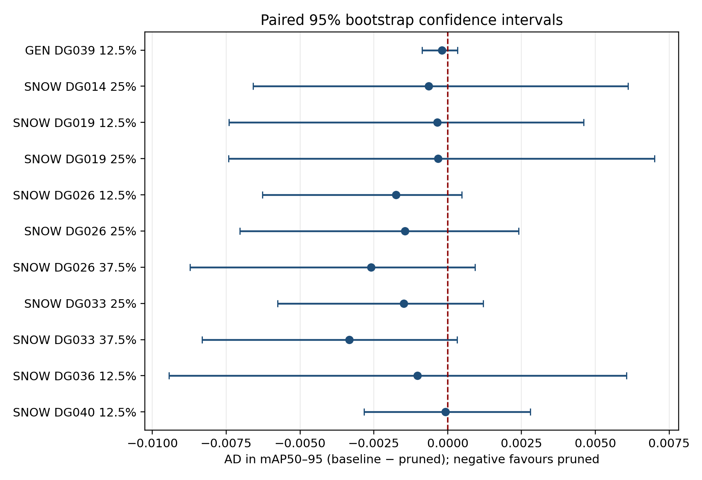
Description. The dashed line is AD = 0. An interval that crosses zero is statistically unresolved. A robust fixed-split improvement requires the complete interval to remain below zero.
Table 9. Paired bootstrap results
Domain | Group | Ratio | Point AD | 95% CI | Conclusion
GEN | DG039 | 12.5% | -0.000197 | [-0.00087, +0.00033] | Unresolved
SNOW | DG019 | 12.5% | -0.000360 | [-0.00741, +0.00461] | Unresolved
SNOW | DG026 | 12.5% | -0.001748 | [-0.00628, +0.00048] | Unresolved
SNOW | DG036 | 12.5% | -0.001027 | [-0.00943, +0.00605] | Unresolved
SNOW | DG040 | 12.5% | -0.000078 | [-0.00284, +0.00280] | Unresolved
SNOW | DG014 | 25% | -0.000638 | [-0.00659, +0.00610] | Unresolved
SNOW | DG019 | 25% | -0.000326 | [-0.00742, +0.00701] | Unresolved
SNOW | DG026 | 25% | -0.001442 | [-0.00704, +0.00240] | Unresolved
SNOW | DG033 | 25% | -0.001482 | [-0.00576, +0.00120] | Unresolved
SNOW | DG026 | 37.5% | -0.002589 | [-0.00873, +0.00093] | Unresolved
SNOW | DG033 | 37.5% | -0.003340 | [-0.00832, +0.00032] | Unresolved
Description. The confidence analysis confirmed 0 of 11 cases as a robust improvement under this resampling design. Cases whose interval crosses zero remain valid negative measurements, but not proven accuracy gains.

7. Class and object-size diagnosis
SNOW mAP50–95 is a macro-average over eight classes. Rare classes therefore receive the same weight as common classes. In the 100-image validation split, rider has 2 objects, train 10, bicycle 10, bus 12 and motorcycle 16. A small gain on one of these classes can offset damage to car or person in the final macro-average.
Table 10. Largest class gain and harm in each negative case
Domain | Group | Ratio | Largest gain (objects) | Δ AP | Largest harm (objects) | Δ AP
GEN | DG039 | 12.5% | non_motorized_vehicle (214) | +0.0027 | work_van (838) | -0.0012
SNOW | DG019 | 12.5% | train (10) | +0.0119 | truck (41) | -0.0046
SNOW | DG026 | 12.5% | train (10) | +0.0130 | car (559) | -0.0001
SNOW | DG036 | 12.5% | motorcycle (16) | +0.0101 | train (10) | -0.0077
SNOW | DG040 | 12.5% | motorcycle (16) | +0.0025 | train (10) | -0.0058
SNOW | DG014 | 25% | truck (41) | +0.0108 | car (559) | -0.0129
SNOW | DG019 | 25% | train (10) | +0.0202 | truck (41) | -0.0126
SNOW | DG026 | 25% | train (10) | +0.0127 | truck (41) | -0.0013
SNOW | DG033 | 25% | train (10) | +0.0069 | car (559) | -0.0022
SNOW | DG026 | 37.5% | train (10) | +0.0201 | car (559) | -0.0001
SNOW | DG033 | 37.5% | motorcycle (16) | +0.0123 | car (559) | -0.0028
Description. Positive Δ AP means the class improved after pruning. Several aggregate gains are led by low-support classes, while another class is harmed. This is a class trade-off, not uniform improvement.
Table 11. COCO object-size accuracy drops
Domain | Group | Ratio | AD small | AD medium | AD large
GEN | DG039 | 12.5% | -0.0009 | -0.0001 | -0.0008
SNOW | DG019 | 12.5% | +0.0000 | +0.0002 | +0.0001
SNOW | DG026 | 12.5% | +0.0000 | -0.0000 | -0.0029
SNOW | DG036 | 12.5% | -0.0002 | -0.0038 | +0.0034
SNOW | DG040 | 12.5% | -0.0002 | -0.0017 | +0.0003
SNOW | DG014 | 25% | +0.0016 | -0.0012 | +0.0054
SNOW | DG019 | 25% | -0.0000 | +0.0001 | +0.0006
SNOW | DG026 | 25% | +0.0000 | -0.0000 | -0.0013
SNOW | DG033 | 25% | +0.0002 | -0.0019 | -0.0039
SNOW | DG026 | 37.5% | +0.0000 | -0.0000 | -0.0030
SNOW | DG033 | 37.5% | -0.0000 | -0.0048 | -0.0059
Description. These are secondary pycocotools results using COCO small/medium/large area definitions and maxDets = 300. A negative value means that size category improved. The primary study metric remains Ultralytics FP32 mAP50–95.

8. Controlled Batch Normalization ablation
The BN ablation tests whether stale running statistics explain the sign. Each model used the same 400 SNOW training images once, in deterministic order, without augmentation, gradients or an optimizer. Running means and variances were reset and recomputed; all other state tensors were hash-checked before and after.
Figure 2. Raw and BN-recalibrated signed AD
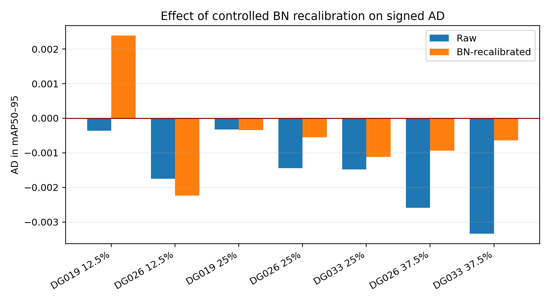
Description. Raw AD compares untouched models. BN AD compares every recalibrated pruned model against the separately recalibrated unpruned control. Negative bars favour the pruned model.
Table 12. BN ablation for repeated priority cases
Group | Ratio | Raw AD | BN-control AD | Negative sign remains
DG019 | 12.5% | -0.000360 | +0.002390 | No
DG026 | 12.5% | -0.001748 | -0.002237 | Yes
DG019 | 25% | -0.000326 | -0.000341 | Yes
DG026 | 25% | -0.001442 | -0.000551 | Yes
DG033 | 25% | -0.001482 | -0.001116 | Yes
DG026 | 37.5% | -0.002589 | -0.000941 | Yes
DG033 | 37.5% | -0.003340 | -0.000639 | Yes
Description. The unpruned SNOW control changed from 0.191981 to 0.156657 mAP50–95. The negative sign remained in 6 of 7 repeated cases. Because BN recalibration harmed the control, it is not an automatic repair. Its value here is diagnostic: the fair comparison is recalibrated pruned versus recalibrated baseline.

9. Findings and methodology decision
Table 13. Hypothesis audit
Possible explanation | Finding | Evidence
AD sign or arithmetic error | Rejected | All AD/NAD arithmetic rechecked; all replay metrics exact.
Wrong checkpoint or dataset | Rejected | Frozen SHA-256 hashes matched for every run.
Different pruning intervention | Rejected | Selected indices and DepGraph operation skeletons matched.
Ordinary rerun randomness | Rejected | All 11 cases reproduced within 1×10⁻¹².
Stale BN statistics alone | Not supported | BN-only recalibration harmed its own control and did not provide a universal correction.
Small-split/class-composition effect | Supported | Ten of 11 cases occur on 100 SNOW images; rare classes often drive the macro change.
True regularization benefit | Unproven | Requires confidence support and replication on an independent snow dataset.
Description. The negative values are real outputs of the frozen pipeline, but the current evidence does not justify treating all of them as generalizable accuracy improvements.
Recommended treatment:
- Keep signed AD in T1 and T2. Replacing negative values would hide a real measured outcome.
- Do not reward a negative AD automatically in the prunability score. Attach a robustness flag: confirmed, unresolved or metric-mixed.
- Use non-negative damage for risk control while preserving the signed value as a separate diagnostic field.
- Treat DG026 and DG033 as follow-up candidates, not proven beneficial groups, unless their confidence interval and independent-dataset result both support the claim.
- Repeat the final selected cases on a second snow dataset or independent split before writing an accuracy-improvement claim.

10. Limitations and next work
- Ho Yin's corrected whole-layer accuracy and board rows are collaborator-reported; the checkpoint is not available for local full-pipeline reproduction.
- The p56 software experiment is complete for both GEN and SNOW, but matched PYNQ-Z2 measurements are still pending. The p56 cross-method comparison is provisional because the available competitor rows were produced with slightly different checkpoints and recovery/evaluation pipelines.
- The p56 T6 and T7 recovery budgets are unequal (30 versus 70 epochs), so they cannot yet determine the better recovery schedule.
- The bootstrap quantifies uncertainty within the existing validation images; it does not replace a new independent dataset.
- SNOW contains only 100 validation images and highly uneven class support.
- The BN ablation uses one pass over 400 training images. It is a diagnostic control, not a tuned recovery method.
- The audit concerns isolated groups. Final cumulative pruning can produce interactions that are not additive.
- Sensitivity and prunability formula approval is separate from this audit; the raw signed evidence should remain available regardless of the final formula.

One-page summary
This week I consolidated the current pruning comparison and completed the negative accuracy-drop audit. At approximately 10.25% parameter reduction, the proposed T6 model retains 98.46% of GEN and 94.72% of SNOW mAP50–95 under the frozen local full-validation pipeline. This is the strongest locally verified dual-domain accuracy result, but T6 removes only about 6% of GFLOPs. In contrast, unrestricted Global L1 removes 35.08% of GEN GFLOPs and gives a matched 34.29% board-latency reduction, while retaining only 77.43% GEN accuracy. The result confirms that parameter reduction alone is not an adequate hardware objective.
Summary table. What is now established
Question | Answer
Best matched 10% accuracy result | Proposed T6: 98.46% GEN and 94.72% SNOW retention.
Main compute limitation | T6 removes about 10.25% of parameters but only about 5.96% of GFLOPs.
Local p56 results | GEN T7: 56.81% parameter and 47.63% GFLOP reduction with 94.62% mAP50-95 retention. SNOW T7: 56.84% parameter and 47.68% GFLOP reduction with 76.79% retention.
Are the signs/arithmetic wrong? | No. All AD and normalized AD calculations were verified.
Can the cases be reproduced? | Yes. All 11 replayed exactly from clean checkpoints.
Are the gains statistically confirmed? | 0 of 11 under the paired bootstrap; other intervals cross zero.
Does BN recalibration solve the issue? | No universal correction. It reduced the unpruned SNOW control substantially.
Most likely explanation | Fixed-split uncertainty and class trade-offs, especially for rare SNOW classes.
Description. The audit separates deterministic reproducibility from statistical robustness. Reproducing a negative value exactly does not by itself make it a generalizable improvement.
The aggressive p56 experiment now has results for both domains. On GEN, staged T7 pruning removes 56.81% of parameters and 47.63% of GFLOPs while retaining 94.62% of baseline mAP50-95 (0.6123 versus 0.6471). On SNOW, the matched architecture retains 76.79%. The GEN result is the strongest currently available p56 accuracy result, but matched hardware measurements and a controlled cross-method rerun remain required.
Across 306 isolated evaluations, 11 AD records are negative: ten on SNOW and one on GEN. All 11 replayed exactly with matching channels and DepGraph operations, but every paired-bootstrap 95% confidence interval crosses zero. The correct reporting decision is therefore to preserve signed AD in the raw tables while treating each negative case as an uncertainty-aware diagnostic, not an automatic accuracy bonus. Independent adverse-weather replication is still required.
The corrected evidence supports negative AD as a small, mostly unstable perturbation effect rather than a dependable pruning benefit. At moderate compression, T6 provides strong accuracy retention; at aggressive p56 compression, staged T7 recovery is the strongest current software candidate. The remaining priorities are matched p56 hardware measurement, controlled competitor reruns, and confirmation on an additional dataset pair.

